Mysql练习题2

Student 表

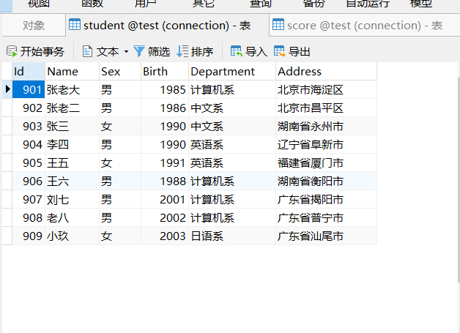

Score 表

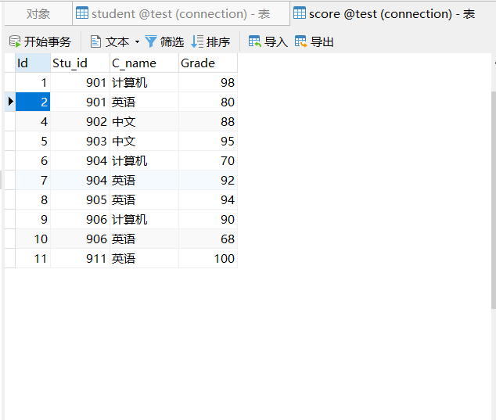

1. 从student表中查询每个院系有多少人

-- 1.从student表中查询每个院系有多少人

select department,count(id) as "人数"

from student

GROUP BY department;

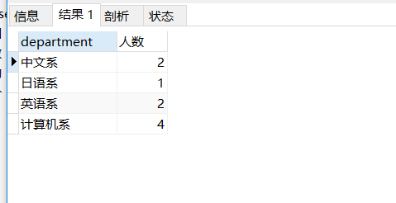

-- 2.从score表中查询每个科目的最高分

select C_name , max(grade)

from score

group by C_name;

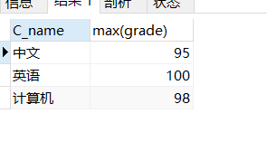

-- 3.查询李四的考试科目（c_name）和考试成绩（grade）

select stu.id , name , c_name , grade

from student stu, score sco

where stu.id = sco.stu_id and name="李四";

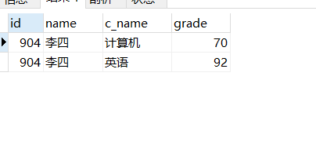

-- 4.计算每个学生的总成绩

select stu.id , name , sum(grade)

from student stu , score sco

where stu.id = sco.stu_id

group by stu.id , name;

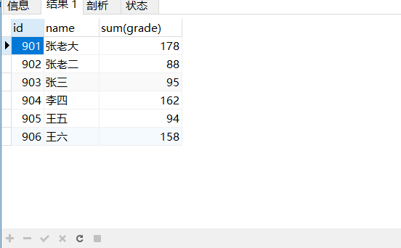

-- 5.计算每个考试科目的平均成绩

select C_name , round(Avg(grade),1) as "平均值"

from score

group by C_name;

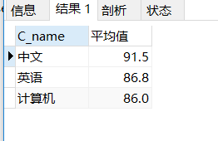

-- 6.查询计算机成绩低于95的学生信息

select stu.id,stu.name,stu.sex,stu.birth,stu.department,stu.address,sc.C_name,sc.grade

from student stu , (select stu_id,C_name,Grade from score where grade<95 and C_name = "计算机") sc

where stu.id = sc.stu_id;

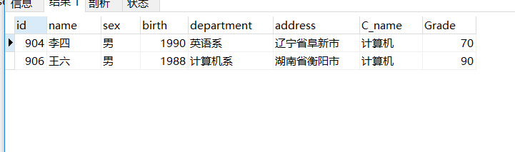

-- 7.查询同时参加计算机和英语考试的学生的信息

select stu.id,stu.name,stu.sex,stu.birth,stu.department,stu.address

from student stu,(select stu_id , count(stu_id) as "count" from score

where C_Name in("计算机","英语")

group by stu_id having count =2 ) sc

where stu.id = sc.stu_id;

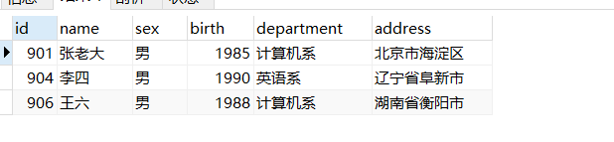

-- 8.将计算机考试成绩按从高到低进行排序

select *

from score

where c_name = "计算机"

order by grade desc;

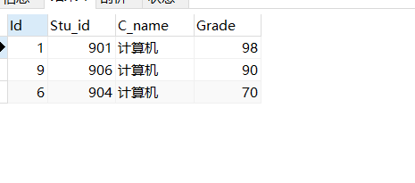

-- 9.查询姓张或者姓王的同学的姓名、院系和考试科目及成绩

select stu.name,stu.department,sc.C_name,sc.grade

from student stu ,score sc

where stu.id = sc.stu_id and (stu.name like "张%" or stu.name like "王%");

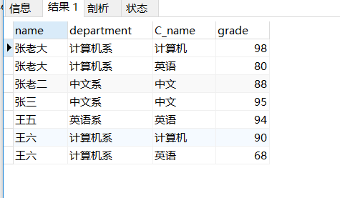

-- 10.查询都是湖南的学生的姓名、年龄、院系和考试科目及成绩

select stu.name,stu.sex,stu.department,sc.C_name,sc.grade,stu.address

from student stu ,score sc

where stu.id = sc.stu_id and stu.Address like "湖南%"

